Steps to Install VMware Workstation 17 on Windows 10:
- Download VMware Workstation 17:
  - Open a web browser and go to website: https://getintopc.com/softwares/virtualization/vmware-workstation-pro-2024-free-download/
  - Click on Download Now and select Workstation 17 Pro for Windows.
  - Save the file to your preferred download location.
- Run the Installer:
  - Once the download is complete, navigate to the folder where you saved the file (usually Downloads).
  - Double-click on the file (VMware-workstation-full-17.16.0.exe) to run the installer.
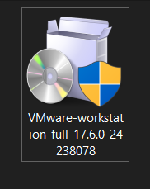
- VMware Installation Wizard:
  - The VMware Workstation Setup Wizard will open. Click Next to proceed.
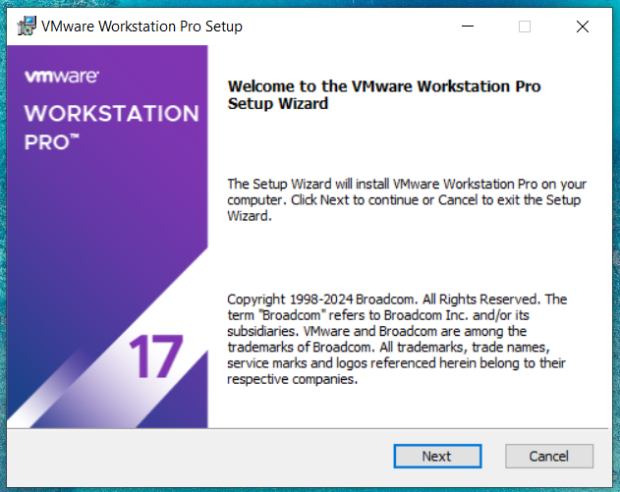
- License Agreement:
  - Read through the End User License Agreement.
  - Check the box to Accept the terms in the License Agreement, then click Next.
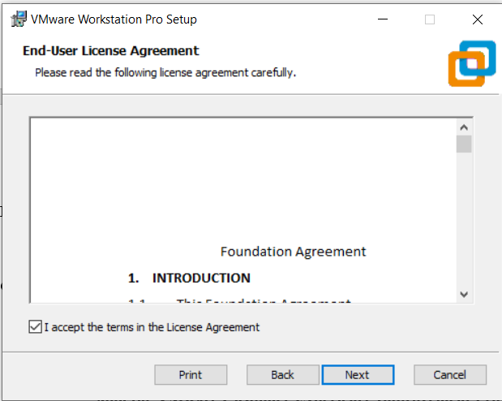
- Custom Setup Options:
  - On the Custom Setup page, choose the following options:
    - Enhanced Keyboard Driver: You can enable this if needed for specific keyboard enhancements.
    - Check for product updates on startup: Leave this checked to keep your VMware updated.
    - Join the VMware Customer Experience Improvement Program: Optional.
  - Click Next.
- Installation Destination:
  - Choose the installation folder for VMware Workstation. The default path is usually: C:\Program Files (x86)\VMware\VMware Workstation.
  - If you want to install it in a different directory, click Change to select a new location, then click Next.
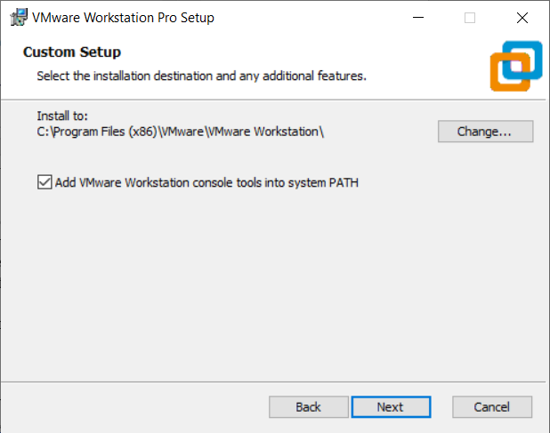

- Shortcuts Setup:
  - Select whether you want to create shortcuts:
    - Desktop Shortcut: Check this if you want quick access from your desktop.
    - Start Menu Program Folder: Leave this checked to easily find VMware in your Start Menu.
  - Click Next.
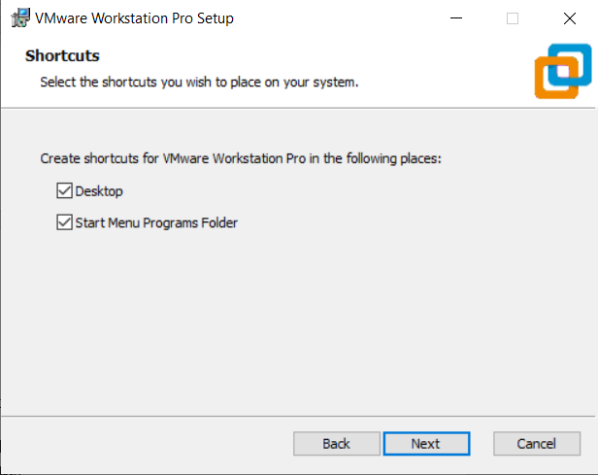
- Ready to Install:
  - Review your installation settings. If everything looks correct, click Install to begin the installation.
- Installation Progress:
  - Wait while the installation proceeds. This might take a few minutes depending on your system.
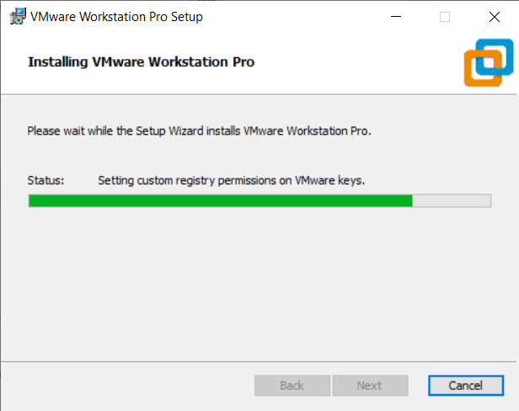

- Complete the Installation:
  - Once the installation is finished, you’ll see a confirmation page. Click Finish to complete the process.
  - If prompted to Restart your system, do so.
- Enter License Key or Use Trial:
  - After restarting, launch VMware Workstation 17.
  - You’ll be prompted to either:
    - Enter a license key (if you have purchased one), or
    - Use the free trial version (for 30 days).
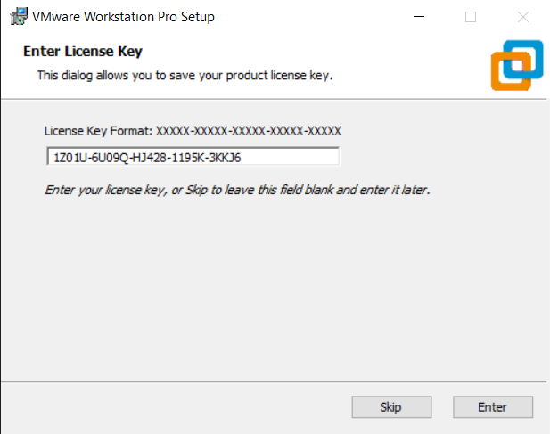

Steps to Install Oracle VM VirtualBox on Windows 10:
- Download VirtualBox:
  - Go to the official VirtualBox website: VirtualBox Downloads.
  - Click on the Windows Hosts link to download the latest version for Windows.
  - Save the installer file to your preferred location.
- Run the Installer:
  - Navigate to the folder where you downloaded the file (usually Downloads).
  - Double-click the installer (VirtualBox-7.0.14-161095-Win.exe) to run it.
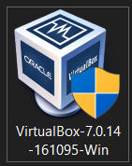
- Start the Setup Wizard:
  - The Oracle VM VirtualBox Setup Wizard will open. Click Next to begin.
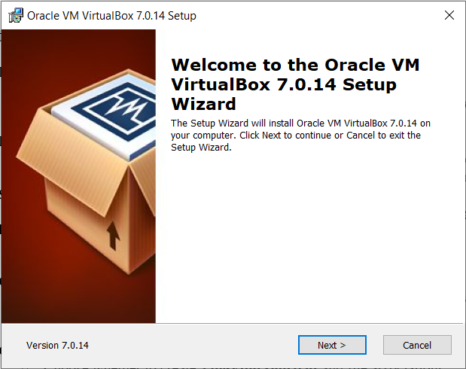
- License Agreement:
  - Review the End User License Agreement.
  - Check the box to Accept the terms, then click Next.
- Custom Setup Options:
  - You can leave the default settings or customize the components you wish to install.
  - Click Next to continue.
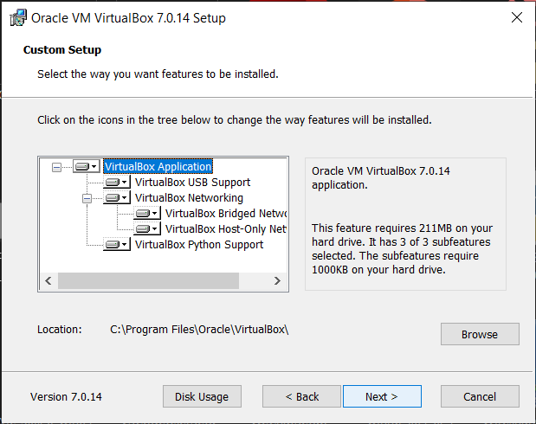
- Create Shortcuts:
  - Choose whether to create a desktop shortcut and file associations.
  - Click Next.
- Network Interfaces Warning:
  - A warning may appear about resetting network interfaces. Click Yes to proceed.
- Ready to Install:
  - Review the settings, then click Install to start the installation process.
- Installation Progress:
  - Wait while VirtualBox installs. This may take a few minutes depending on your system.
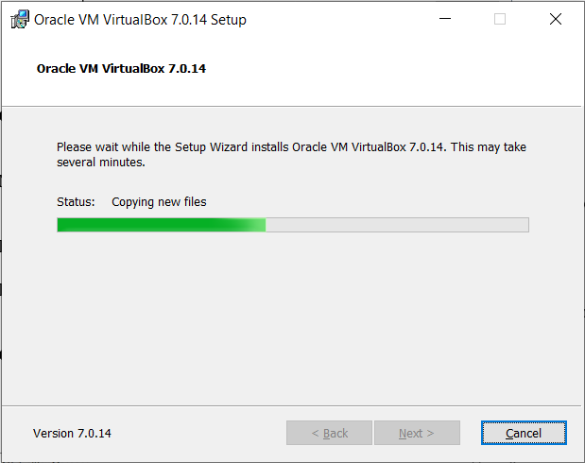
- Complete the Installation:
  - Once the installation is complete, click Finish.
  - You can start Oracle VM VirtualBox immediately if you want.
  - Once finished, click Finish.
